***HCMS Testing***

**My Profile**

* Photo uploading was Successful, But unable to change the photo some time. Kindly share the restrictions if any made for photo upload.
* While applying/approving/rejecting leave, email notification should be sent to reporting manager, candidate & HR. Reason & Remarks should be visible in mail.

**Unable to apply Comp Off.**

* Gets message Comp Off applied successfully, but not able to view the same in my leave status. Neither it’s (notification) been sent to the reporting manager.
* Saturday & Sundays should be weekly offs. Currently it shows as **A** for me on Saturday and **W** on Sunday. For Rajeev both Saturday & Sunday its showing as **A.** For Sat & Sunday It should be weekly Holiday **( WH).**

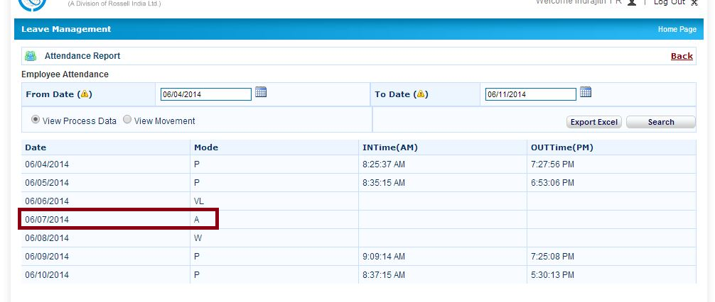

* Normal Holidays should be marked as **H.**
* Leave has to be triggered automatically if an employee is absent and not applied for the absent date.

**Date format should be 01-Jan-2014 format where ever the date is viewable.**

**All the fields should be editable for HCM Super user.**

**Designation Master**

* Unable to add designation "Principal Engineer - Wire Harness" in Company Master.

Wrong employee code for new members.

For e.g. Girish it should start from 2014. from 0117 to 0119 should be starting with 2014.

* Currently employee code and card no is same for all the employees.
* Resigned employees should not be listed in current employee list.
* More Clarity required for each roles in Role Master, i.e the access available for ESS users, Admin, HCM Super User.

**All the fields should be editable by HCM Super user. Edit field required for editing the created records like mark of candidate in 12th& 10th and professional degree and Experience detail.**

* Unable to view address in Company master.
* Unable to edit shift master.
* Inside the Pick Employee, only search from employee name is working.

Search through designation, category & Business Unit is not working.

* Blood groups should be preferable drop down. Unable to enter AB+ve.
* Unable to edit the record from category master.
* Date format has to be changed to DD-MMM-YYYY for all the date fields.
* In personal details spouse DOB field has to be added. (Mandatory for Insurance purpose)
* All the Bank Names should be listed for adding in personal detail.

**Administration 🡪Professional🡪 Educational qualification.**

* Edit field required for editing the current professional details.
* Designation required for Experience details.
* MM-YYYY format (from & to) required for Professional education.
* DD-MMM-YYYY format required for Experience details.
* Experience per company should be automatically calculated in year/month days according to the details filled.

For e.g

Candidate worked with a company from 05-JAN-2010 to 10-APR-2011 has exp of 1year, 3 months, 5 days.

|  |  |  |  |  |  |
| --- | --- | --- | --- | --- | --- |
| **Company** | **Location** | **Designation** | **From** | **To** | **Duration** |
| XY | Mumbai | System Admin | 05-Jan-10 | 10-Apr-11 | 1 Year, 3 months, 5 Days |
| XYZ | Delhi | System Admin | 20-Apr-11 | 25-Dec-12 | 1 Year, 8 months, 5 Days |
| ABC | Bangalore | Sr System Admin | 01-Jan-13 | 10-Jun-14 | 1 Year, 5 months, 10 Days |
| Rossell Techsys | Bangalore | Sr System Admin | 15-Jan-14 | Till Date | 4 months, 25 days |
| **Total Experience** | | | | | **4 Year, 7 months, 15 days** |

Duration should be calculated automatically and current company duration should be automatically incremented day by day.

**Personal Details**🡪 Passport No should with passport expiry date. Once expired please enable the passport field as red.

**Personal Details**🡪 Bank Account No should be only numeric max upto 30 digits

Employees even unmarried should be provisioned to fill children details if adopted. ( Single Mother concept)

**Information Center**

* Text updated in Information center -> From Management Desk is not in correct format.
* Leave management in action items of Home page doesn’t display the leave management page.
* Text uploaded for management desk is not reflecting in correct format.

**Helpful Links**

* Unable to view and delete existing links like movie ticket & unable to add new helpful links**.**

**Reports module is not working.**

* Unable to add pictures in Event master.